**INDADD Submission 2**

**Creating the Database and Inserting the Data**

**Creating and using the Database**

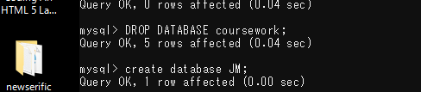

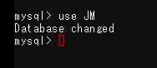

**Table: OUTLET**

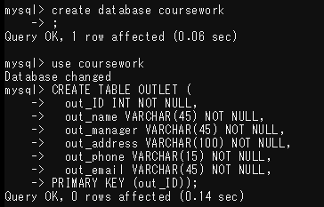

**Table: ACCOUNT**

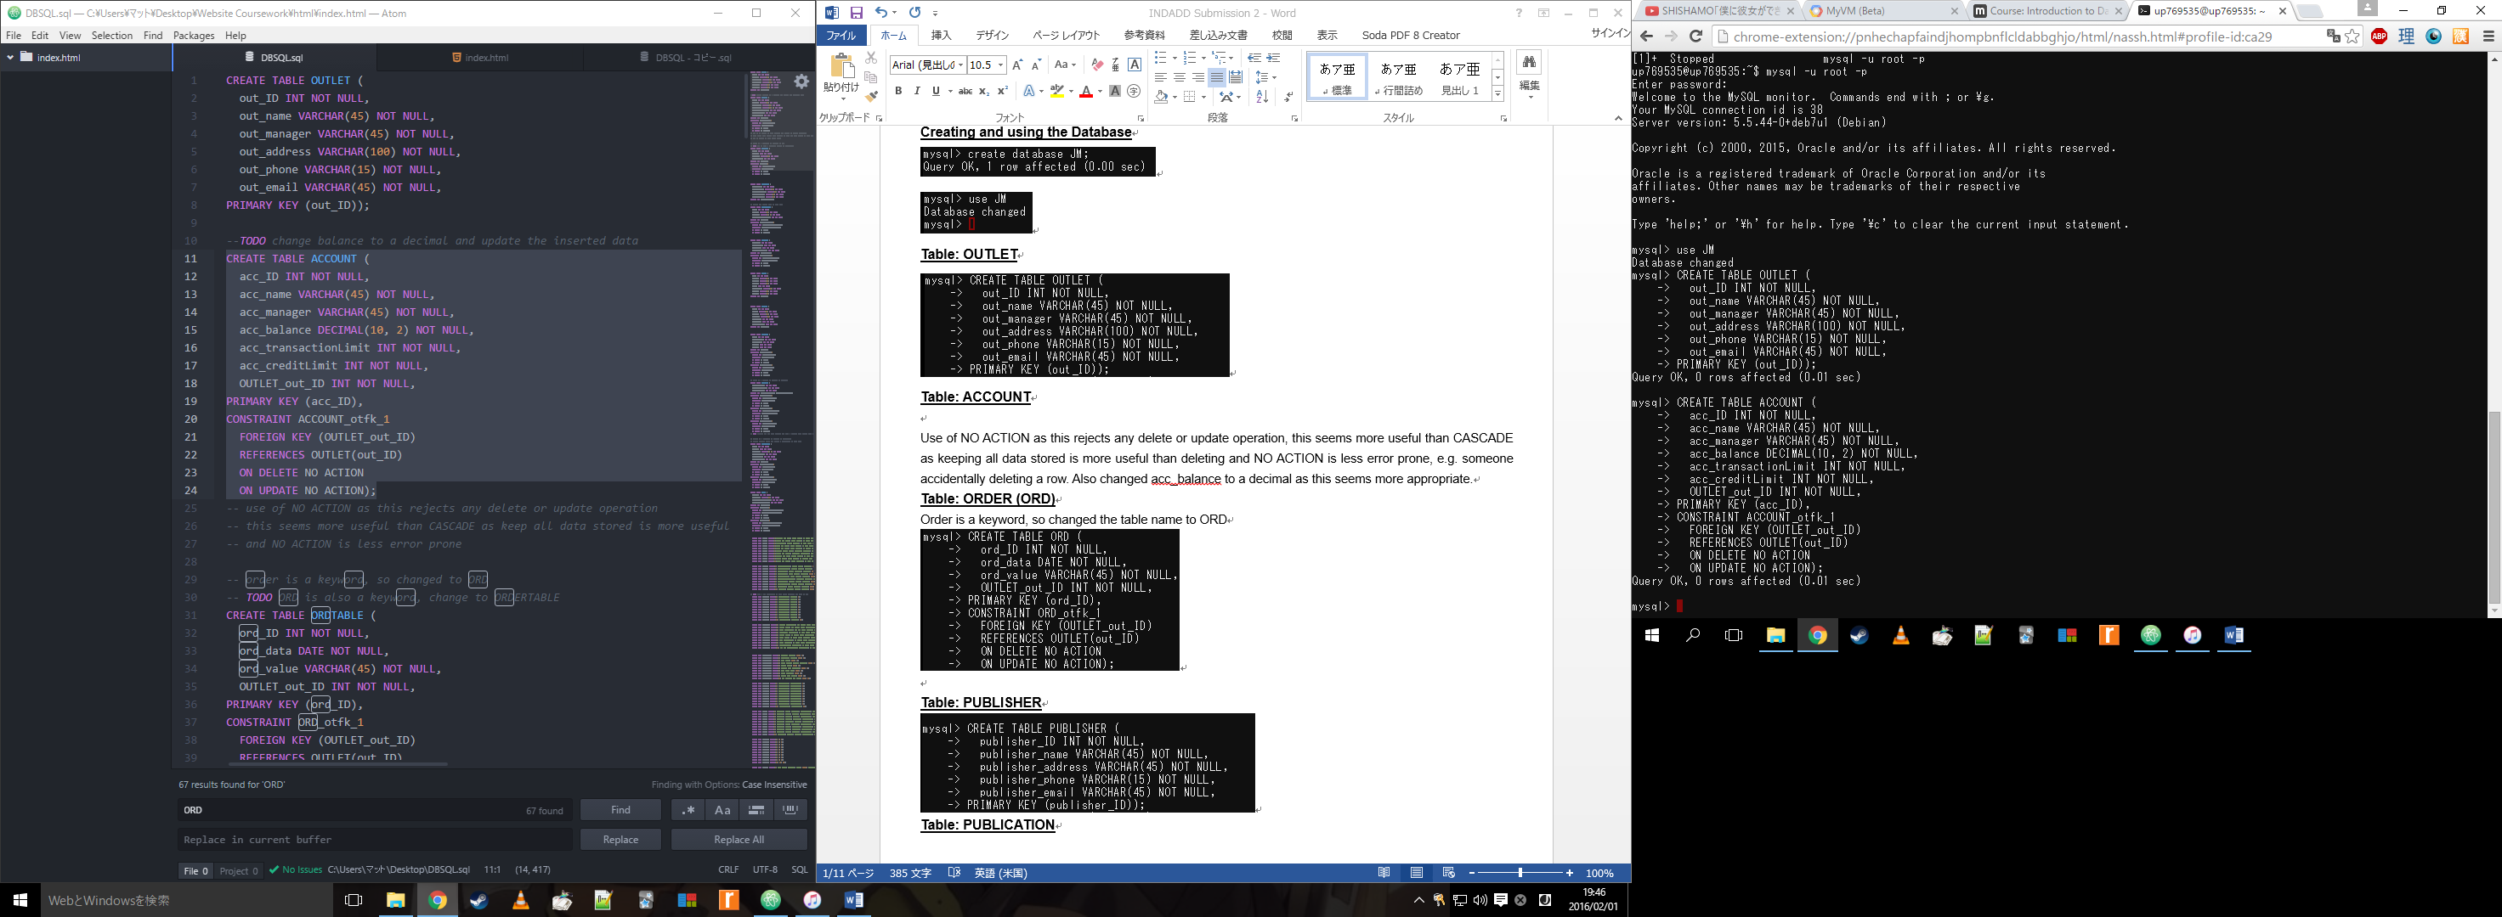

Used NO ACTION as this rejects any delete or update operation, this seems more useful than other options, such as CASCADE, as this is less error prone e.g. someone accidentally deleting something. Also changed acc_balance to a decimal as this seems more appropriate.

**Table: ORDTABLE**

Order is a keyword, so changed the table name to ORDTABLE

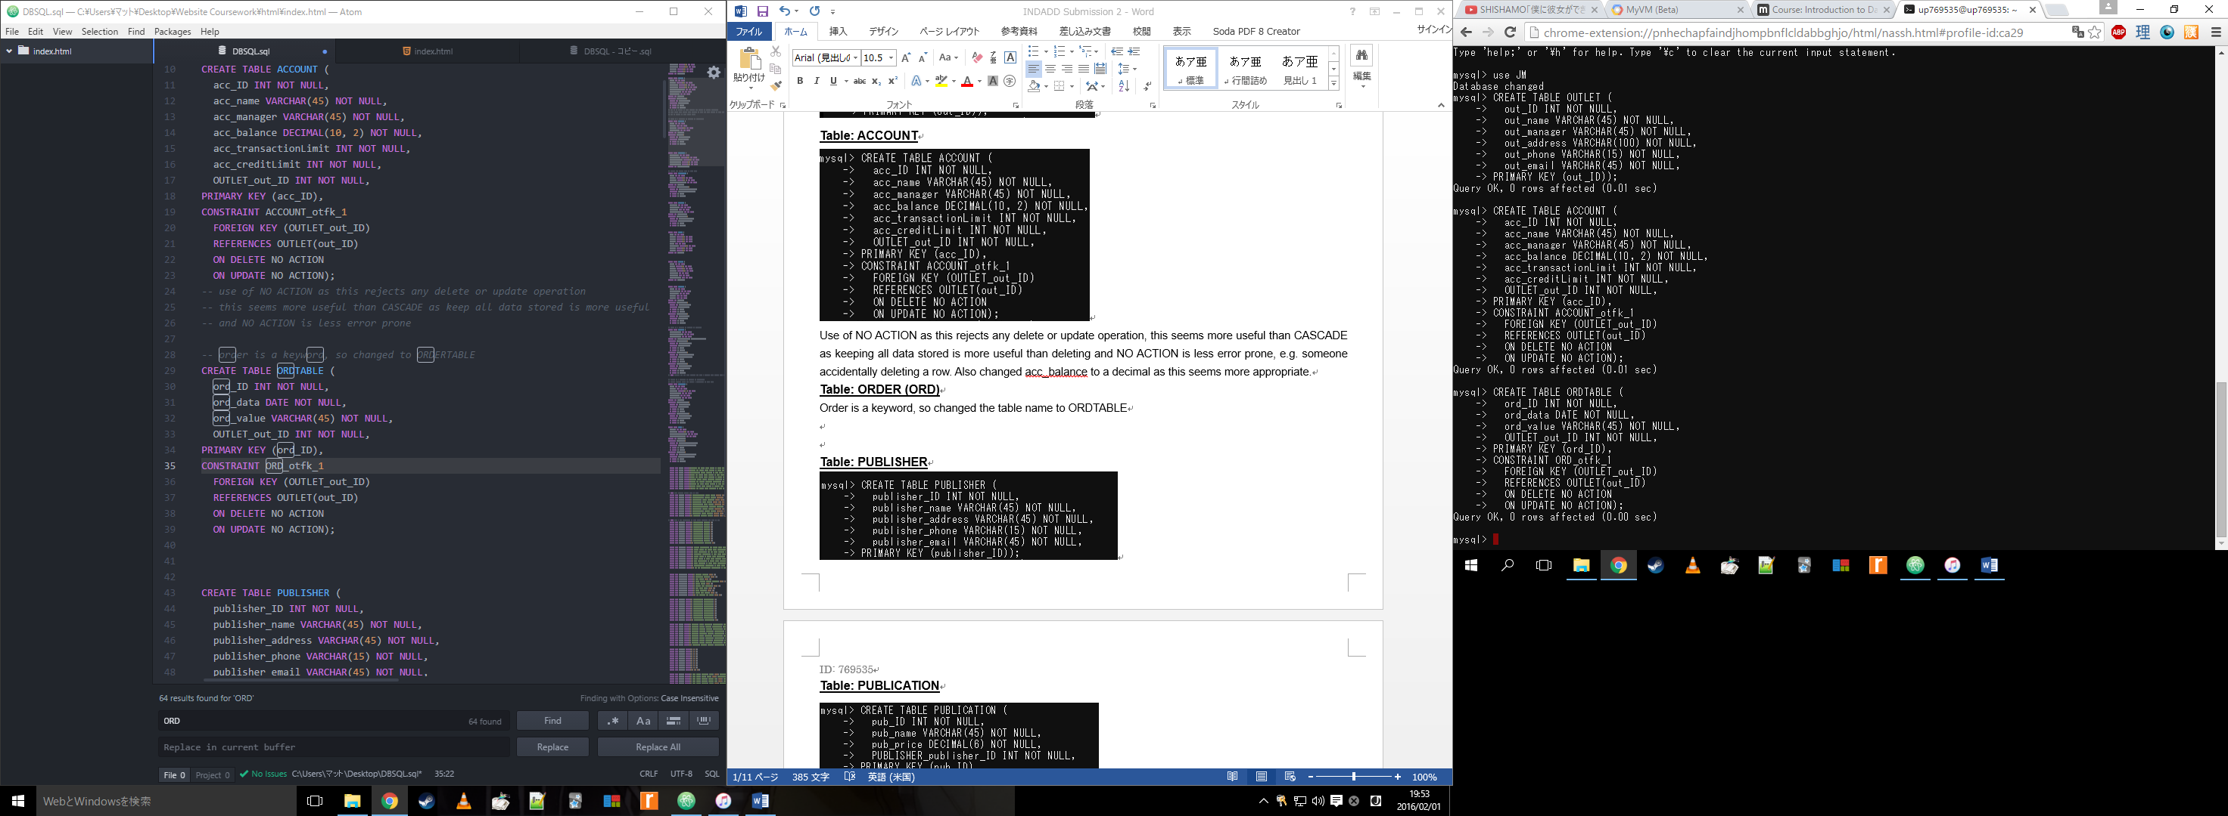

**Table: PUBLISHER**

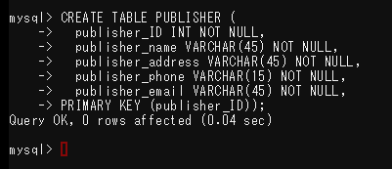

**Table: PUBLICATION**

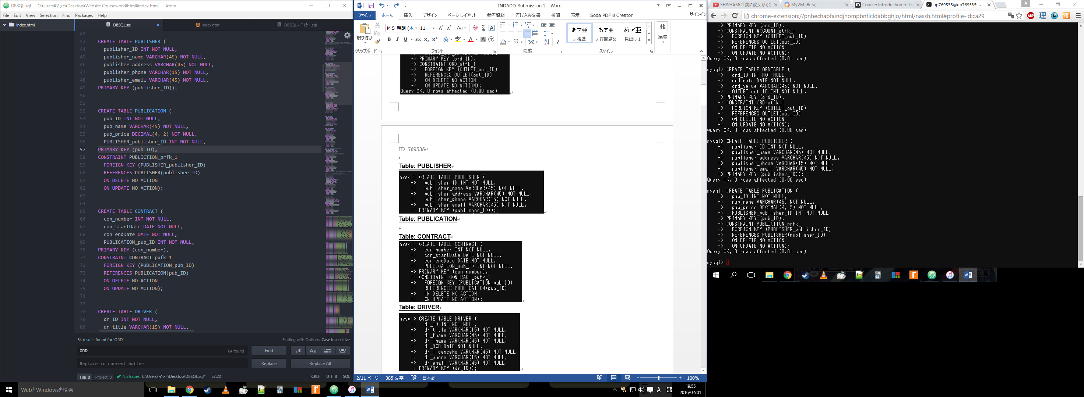

**Table: CONTRACT**

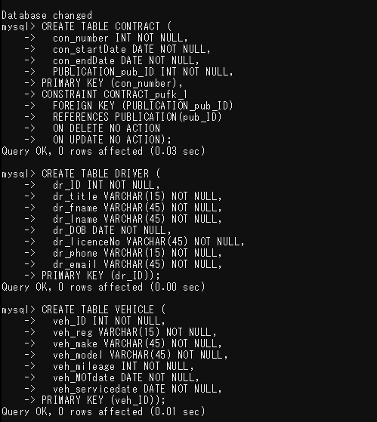

**Table: DRIVER**



**Table: VEHICLE**



**Table: DELIVERY**

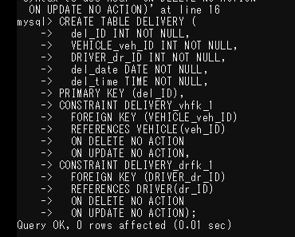

**Table: ORDEROUT**

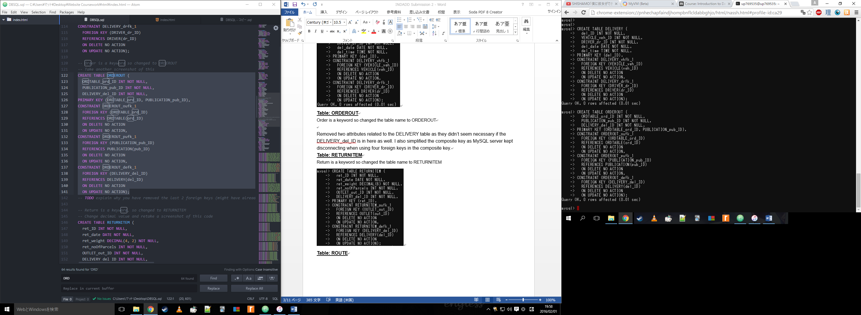

Removed two attributes related to the DELIVERY table as they didn’t seem necessary if the DELIVERY_del_ID is in the table too, as well as this I changed the composite key to ORDTABLE_ord_ ID and PUBLICATION_pub_ID.

**Table: RETURNITEM**

Return is a keyword so changed the table name to RETURNITEM

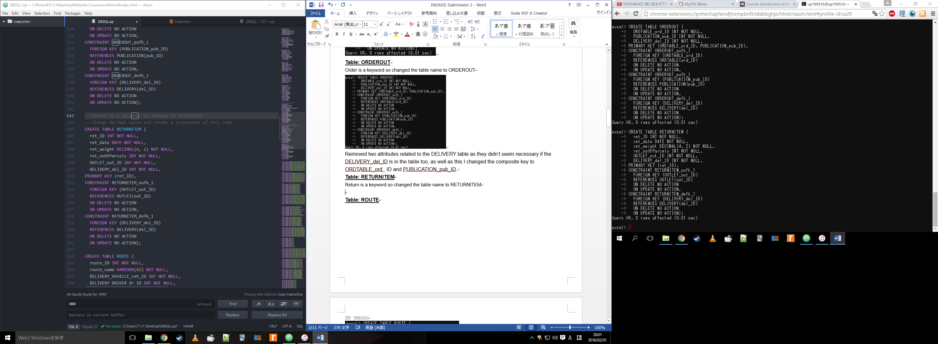

**Table: ROUTE**

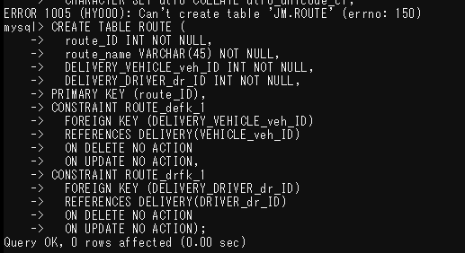

**Tables Check**

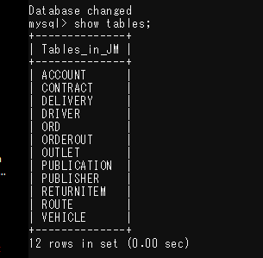

**Inserting Data**

Side note – The colours appear due to my settings in my text editor, they do not affect the code.

**Table: OUTLET**

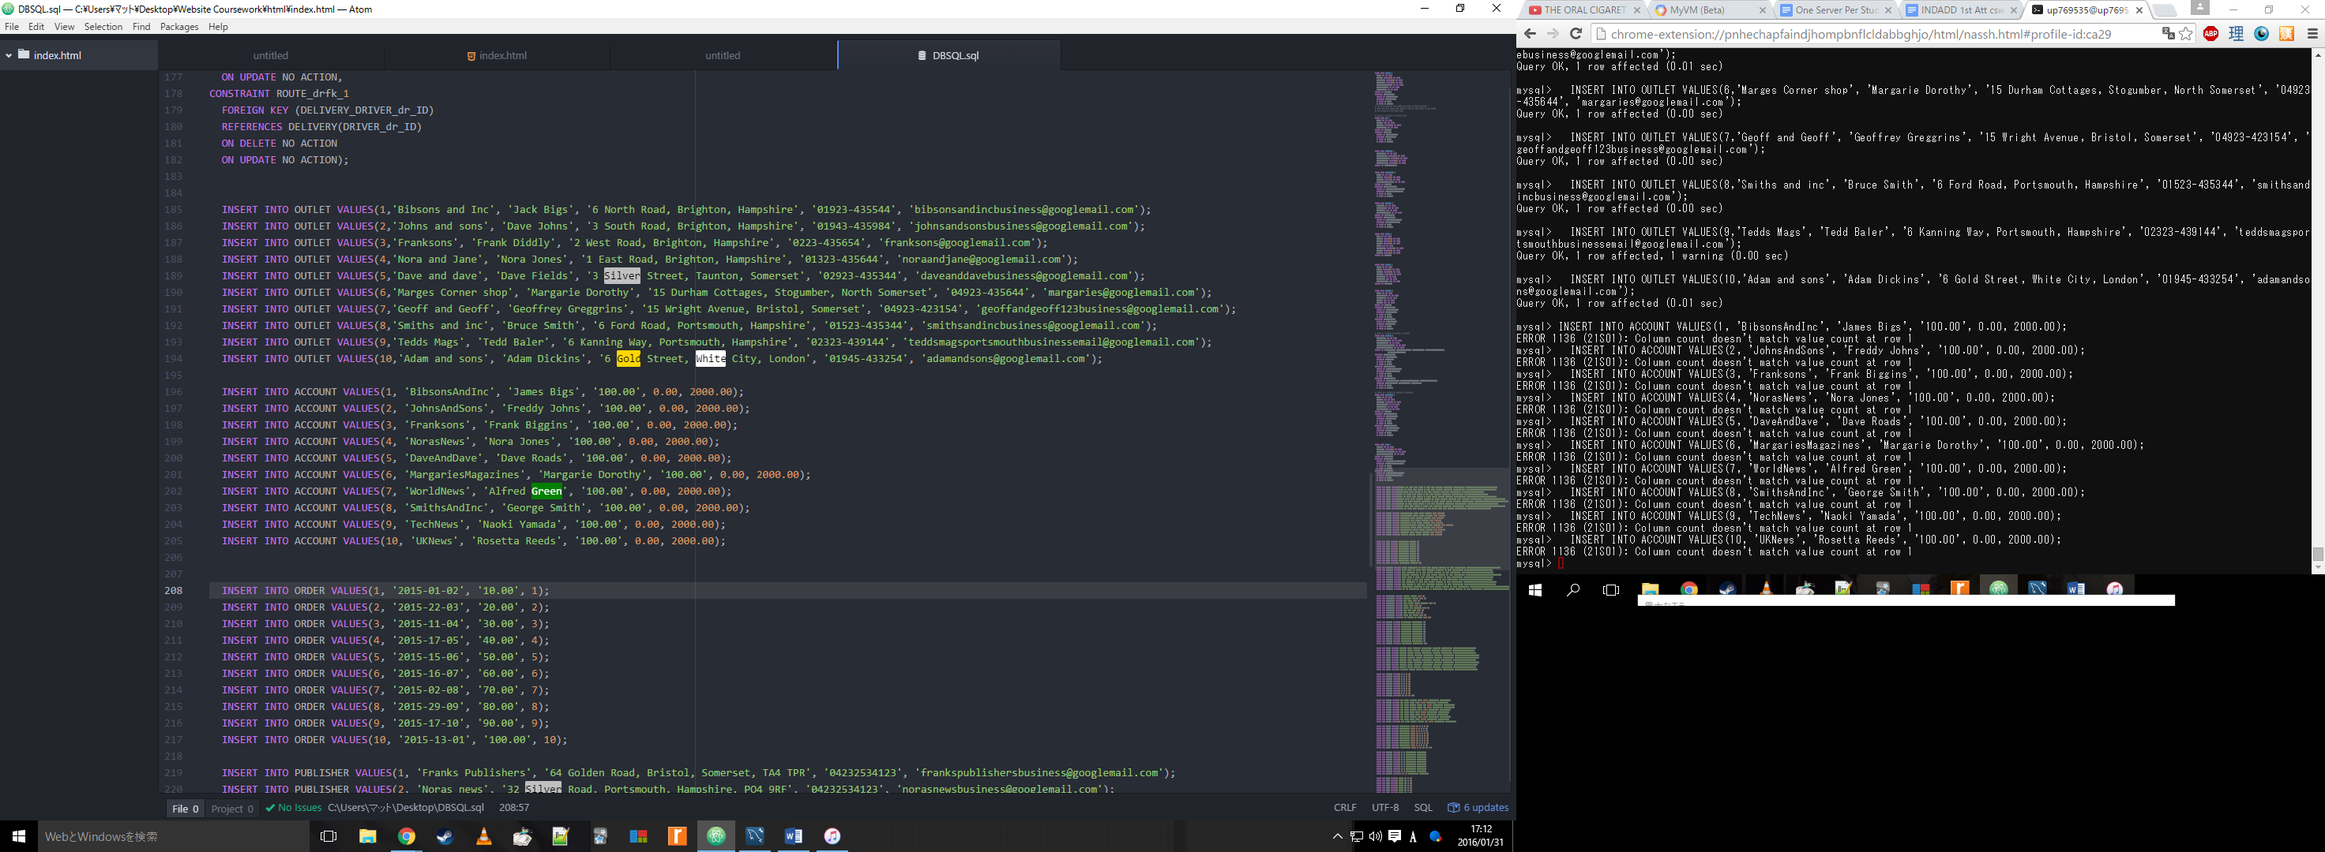

Check:

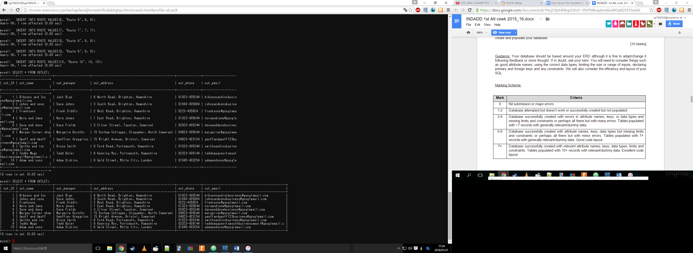

**Table: ACCOUNT**

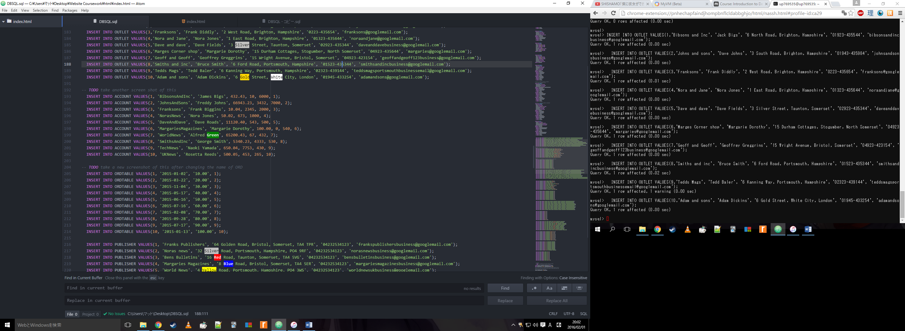

Check:

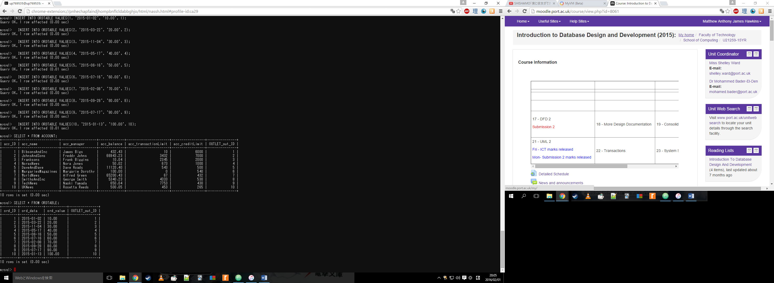

**Table: ORDTABLE**



Check:



**Table: PUBLISHER**

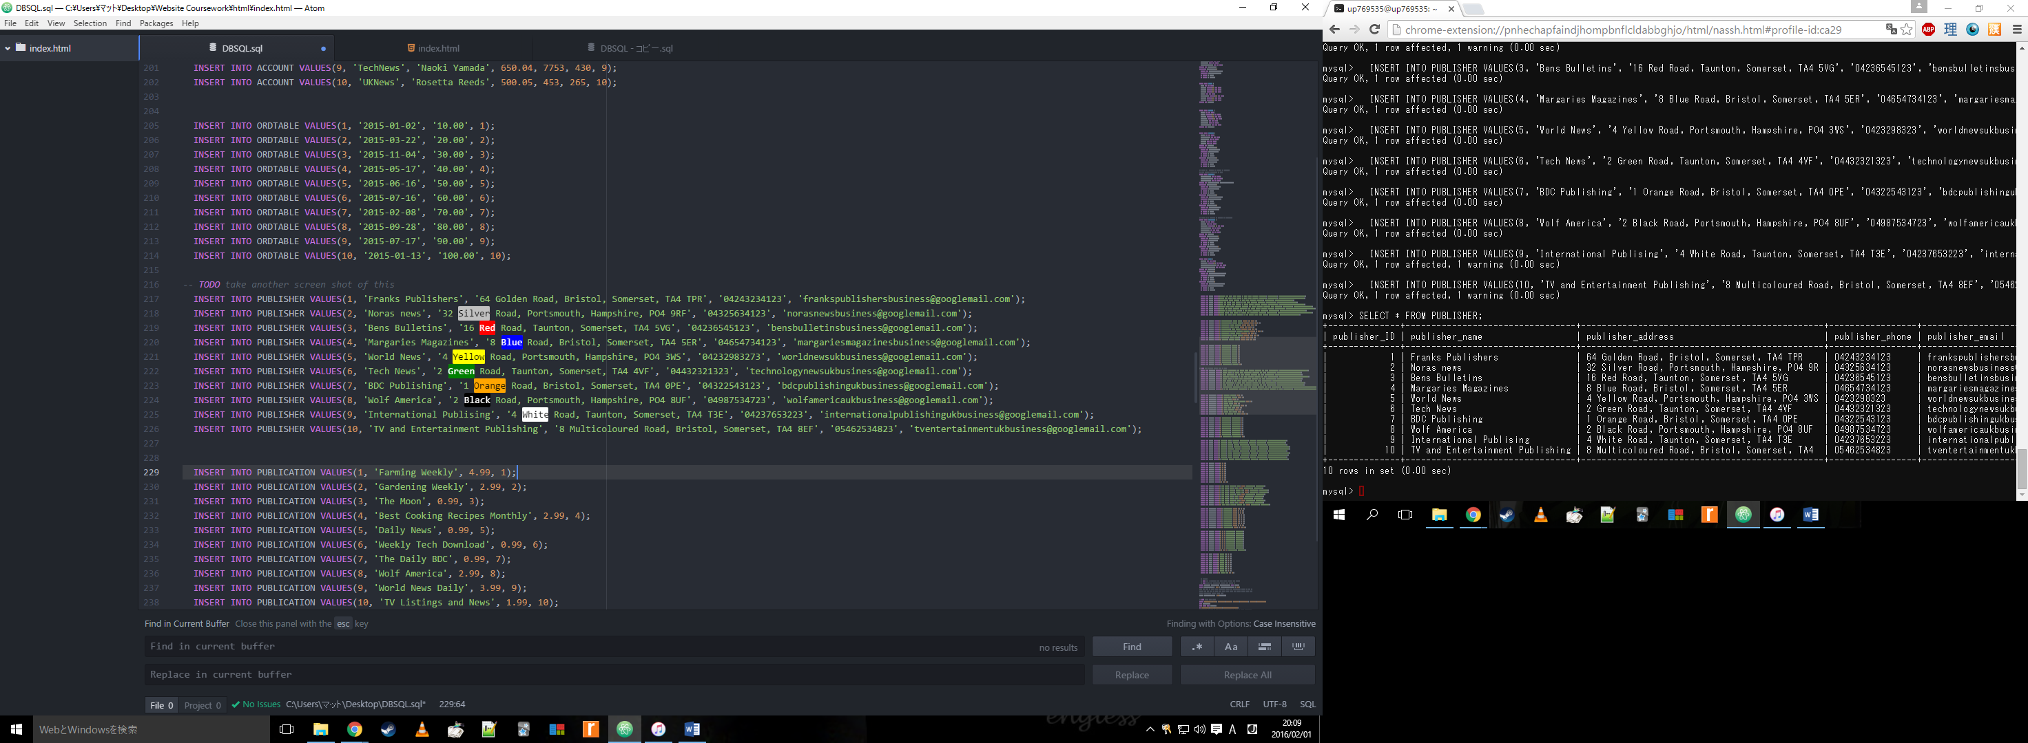

Check:

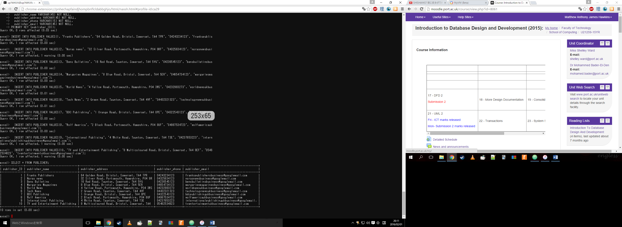

**Table: PUBLICATION**

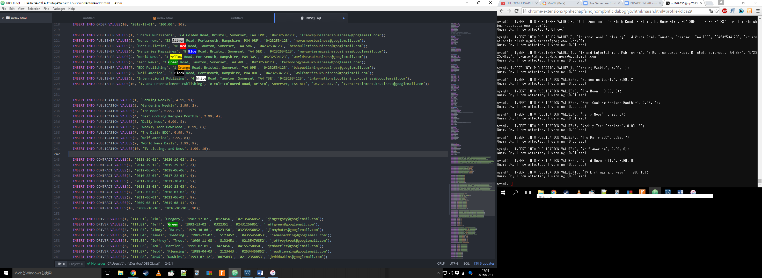

Check:

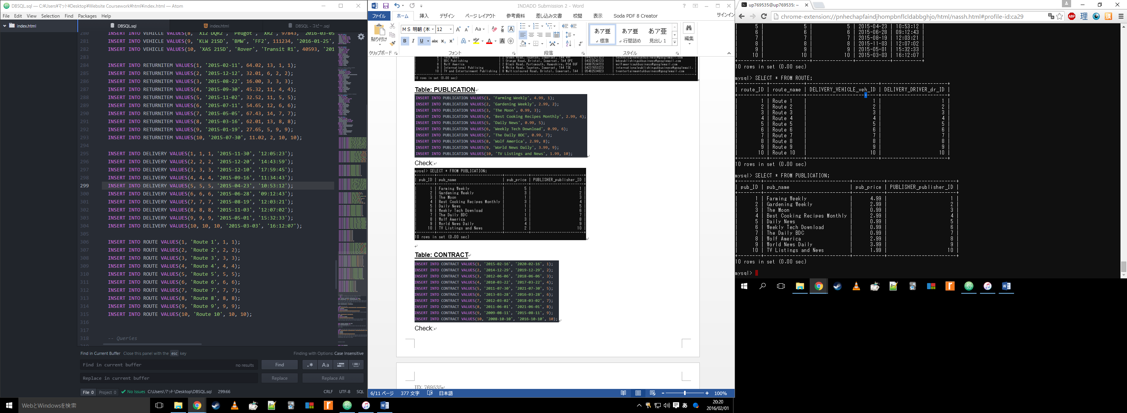

**Table: CONTRACT**

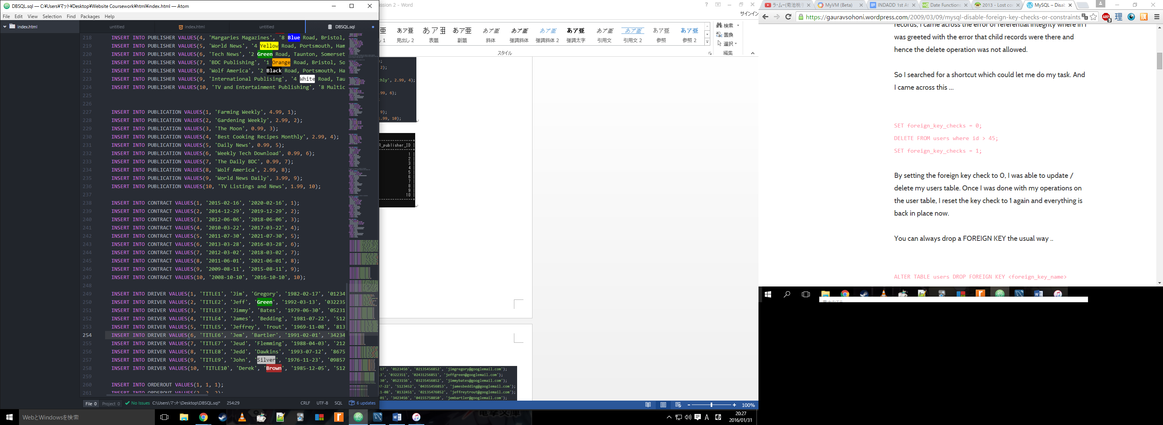

Check:

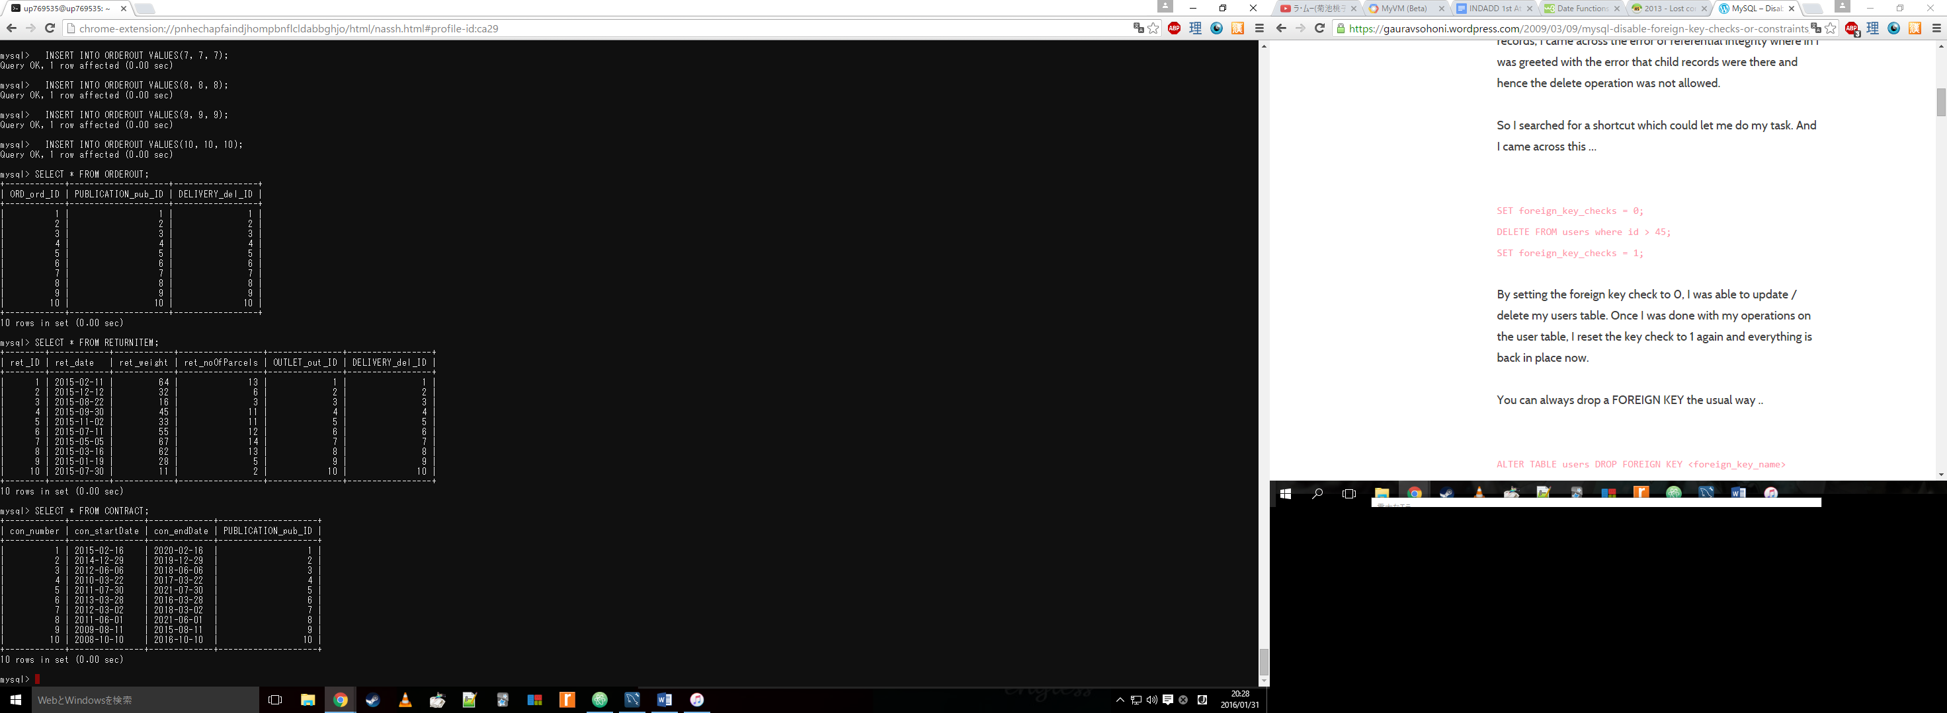

**Table: DRIVER**

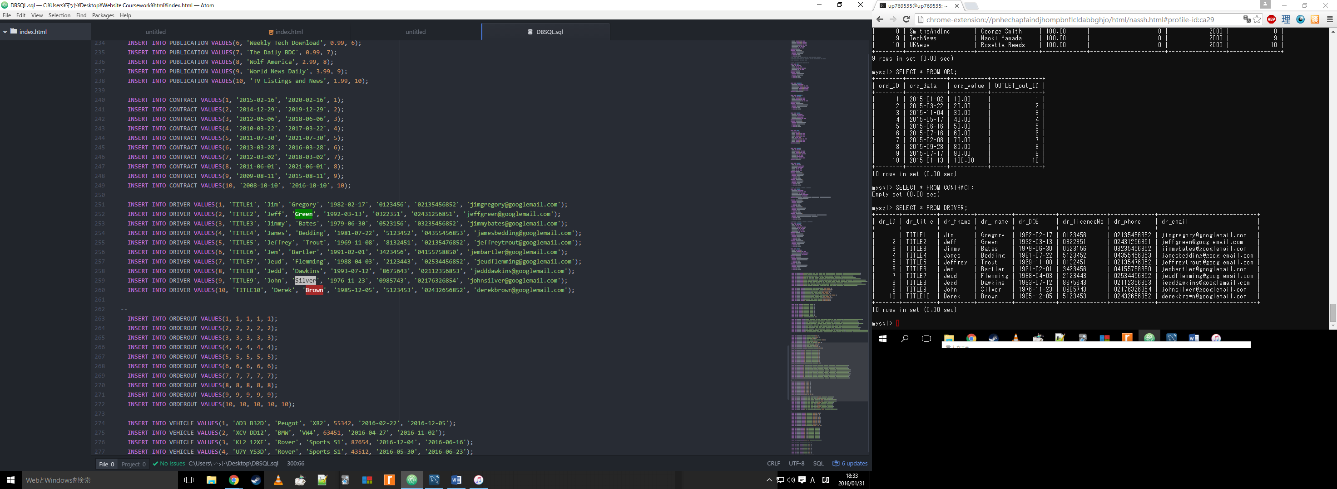

Check:

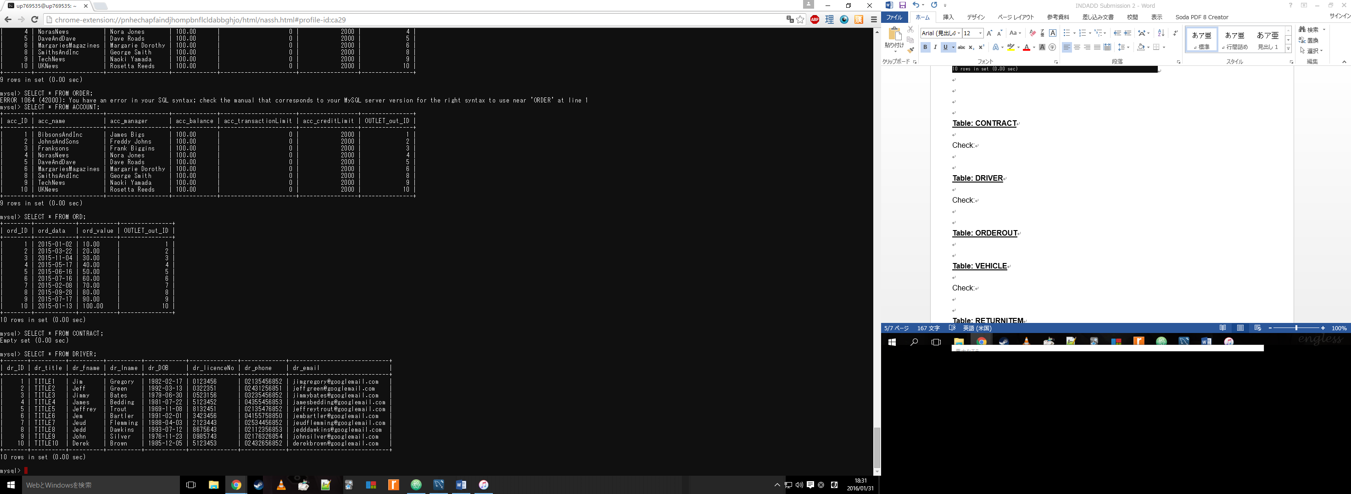

**Table: ORDEROUT**

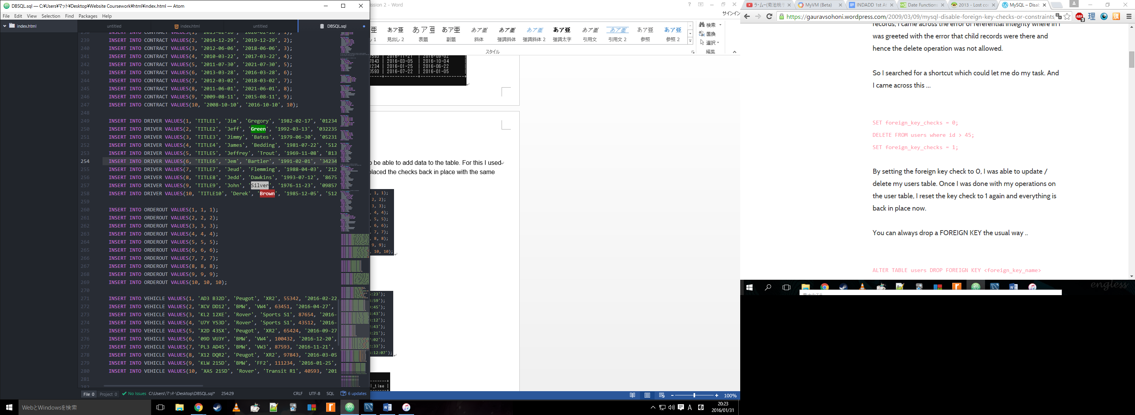

Check:

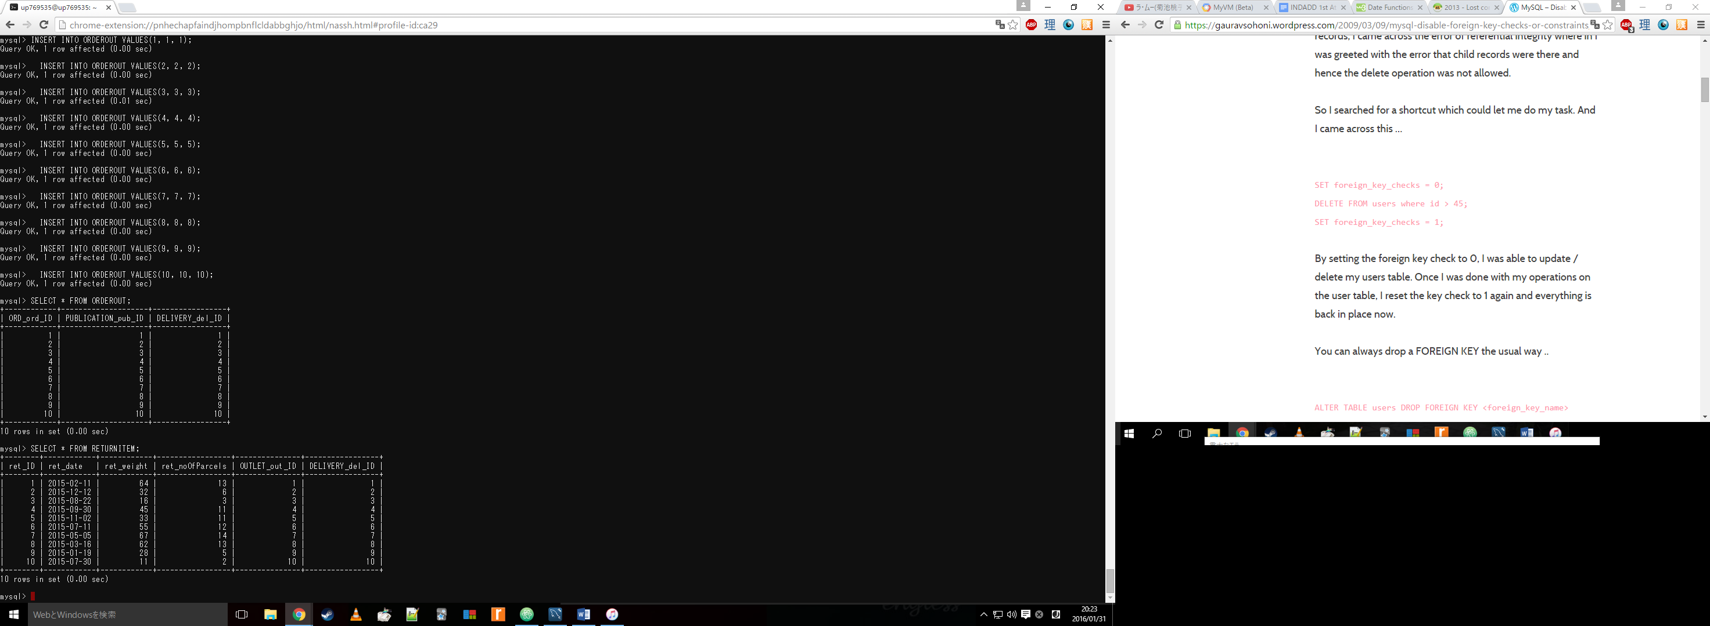

**Table: VEHICLE**

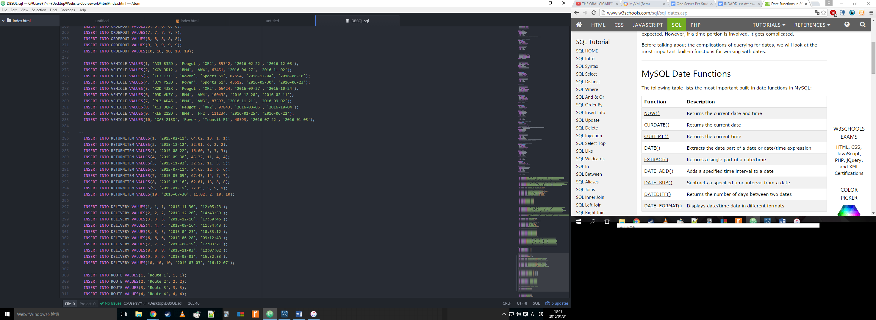

Check:

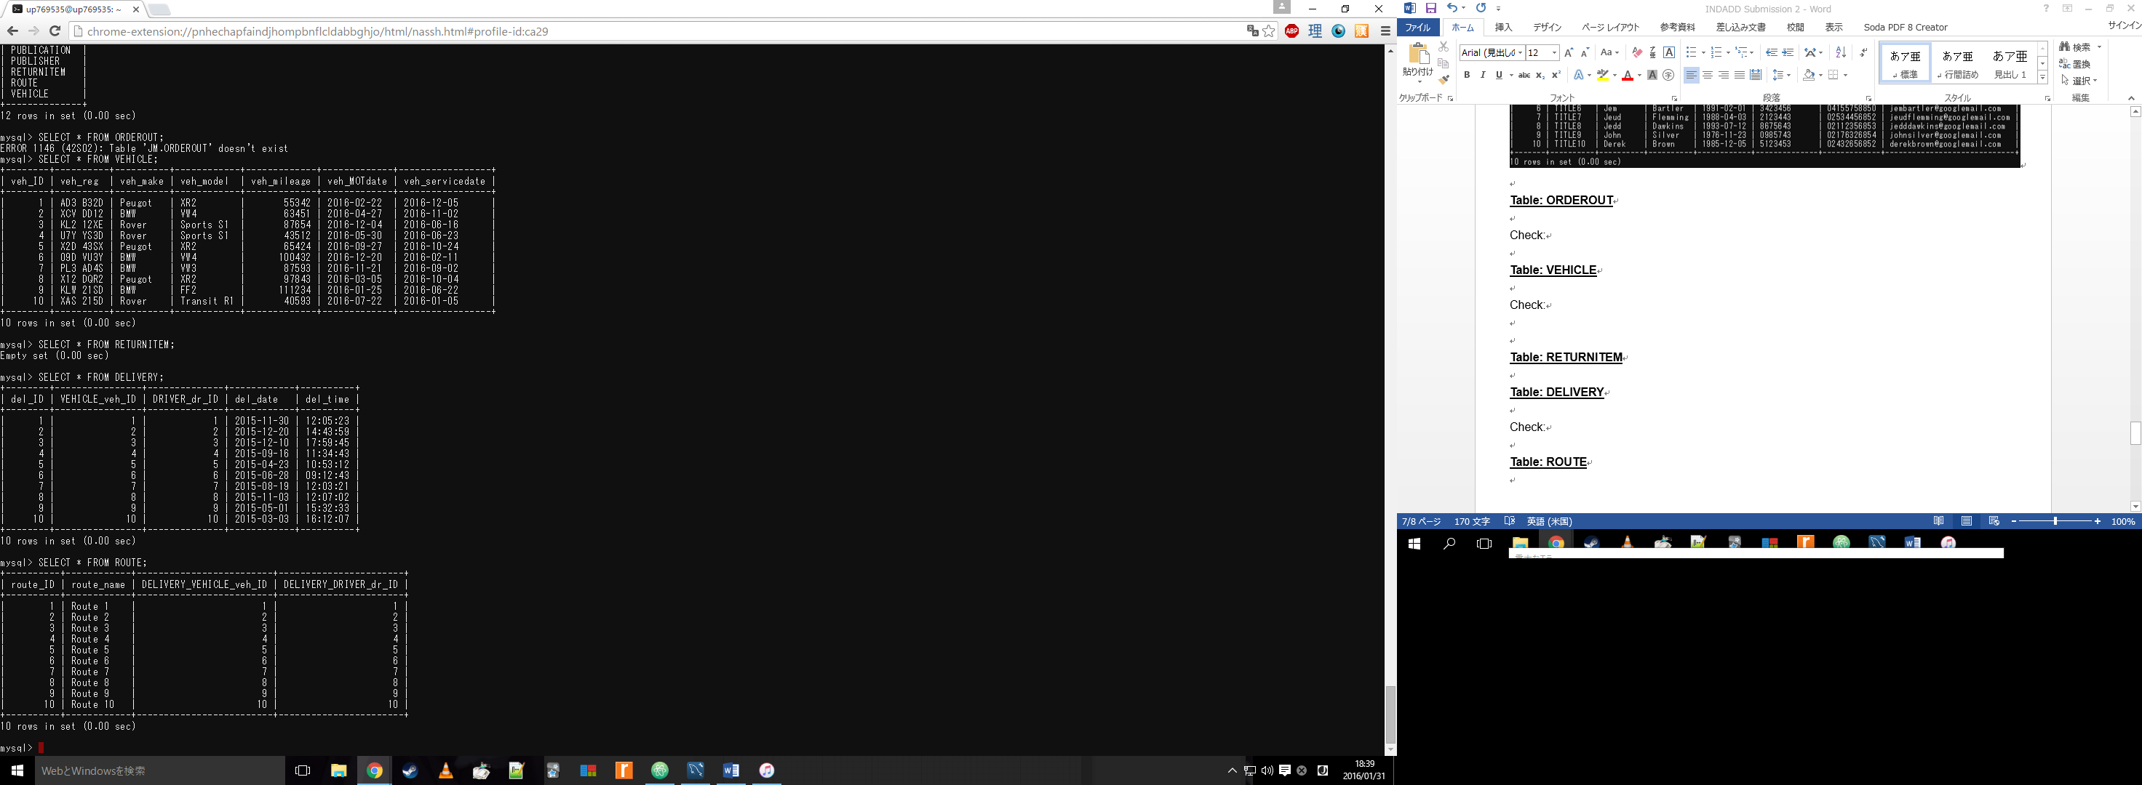

**Table: RETURNITEM**

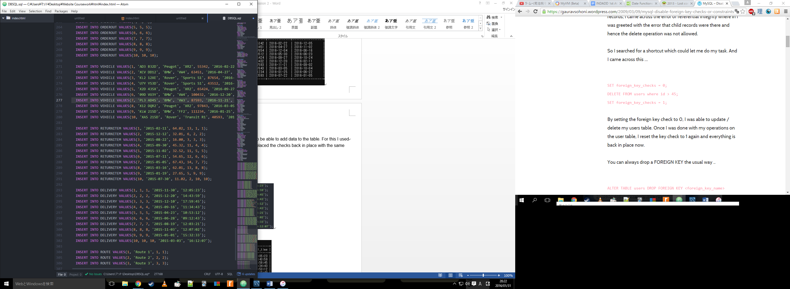

Check:

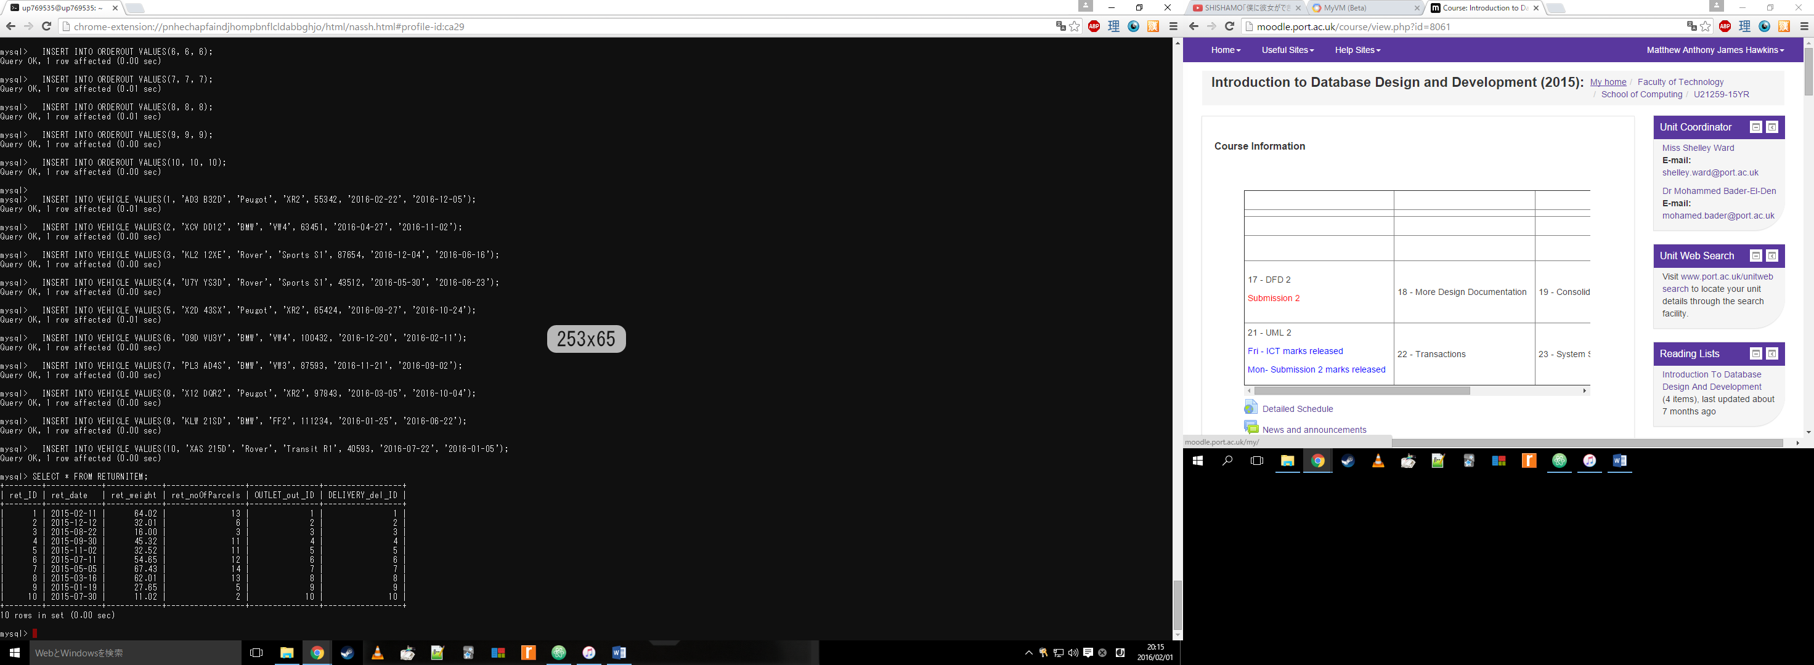

**Table: DELIVERY**



Check:



**Table: ROUTE**

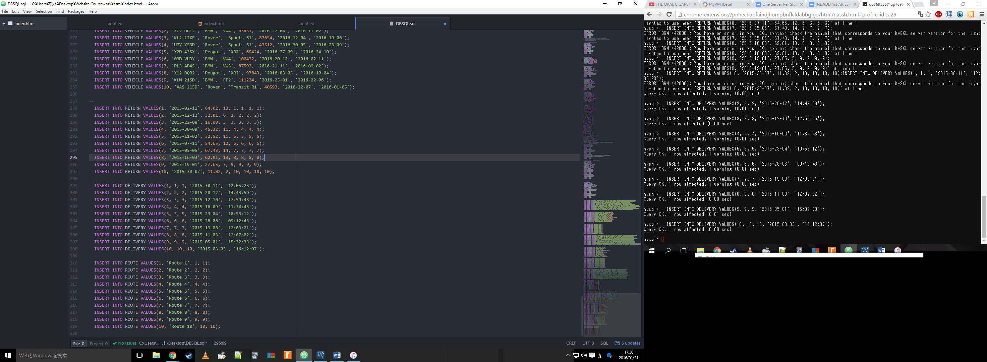

Check:

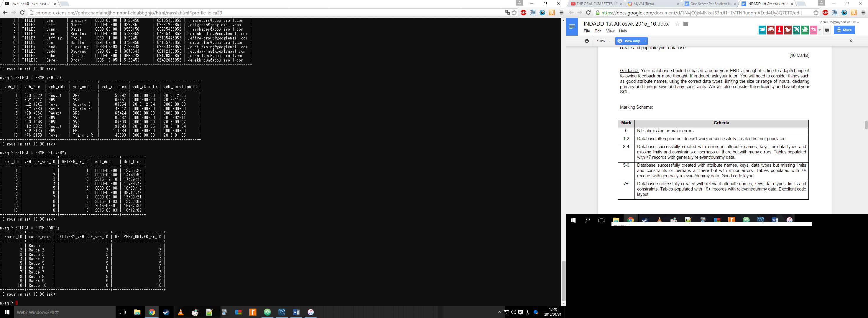

**SQL Queries**

1. πname, balance(σbalance ≤ 200(ACCOUNT))

Screenshot of code and result:

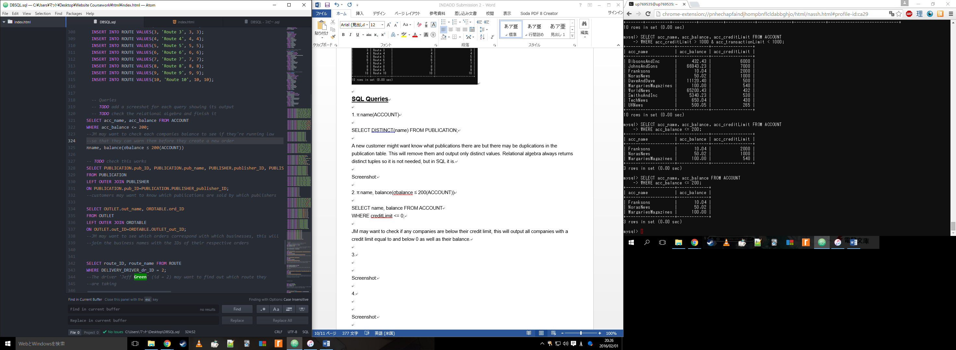

Description:

JM may want to check each companies balance to see if they're running low so that they can warn them before they create a new order

1. πID, name, price, publisherID(σprice < 3.00(PUBLICATION))

Screenshot of code and result:

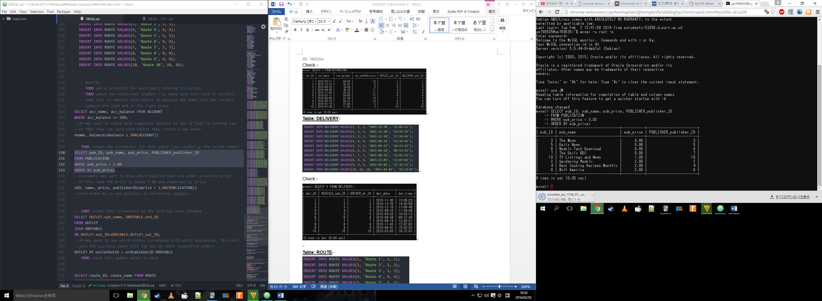

*Note – ORDER BY is not possible in relational algebra but I felt it was useful for stakeholder*

Description:

Customers may want to know which publications are within a certain price, in this case the price is below 3.00 and organised by price.

1. OUTLET ⨝ outletOutID = ordtableOutID ORDTABLE

Screenshot of code and result:

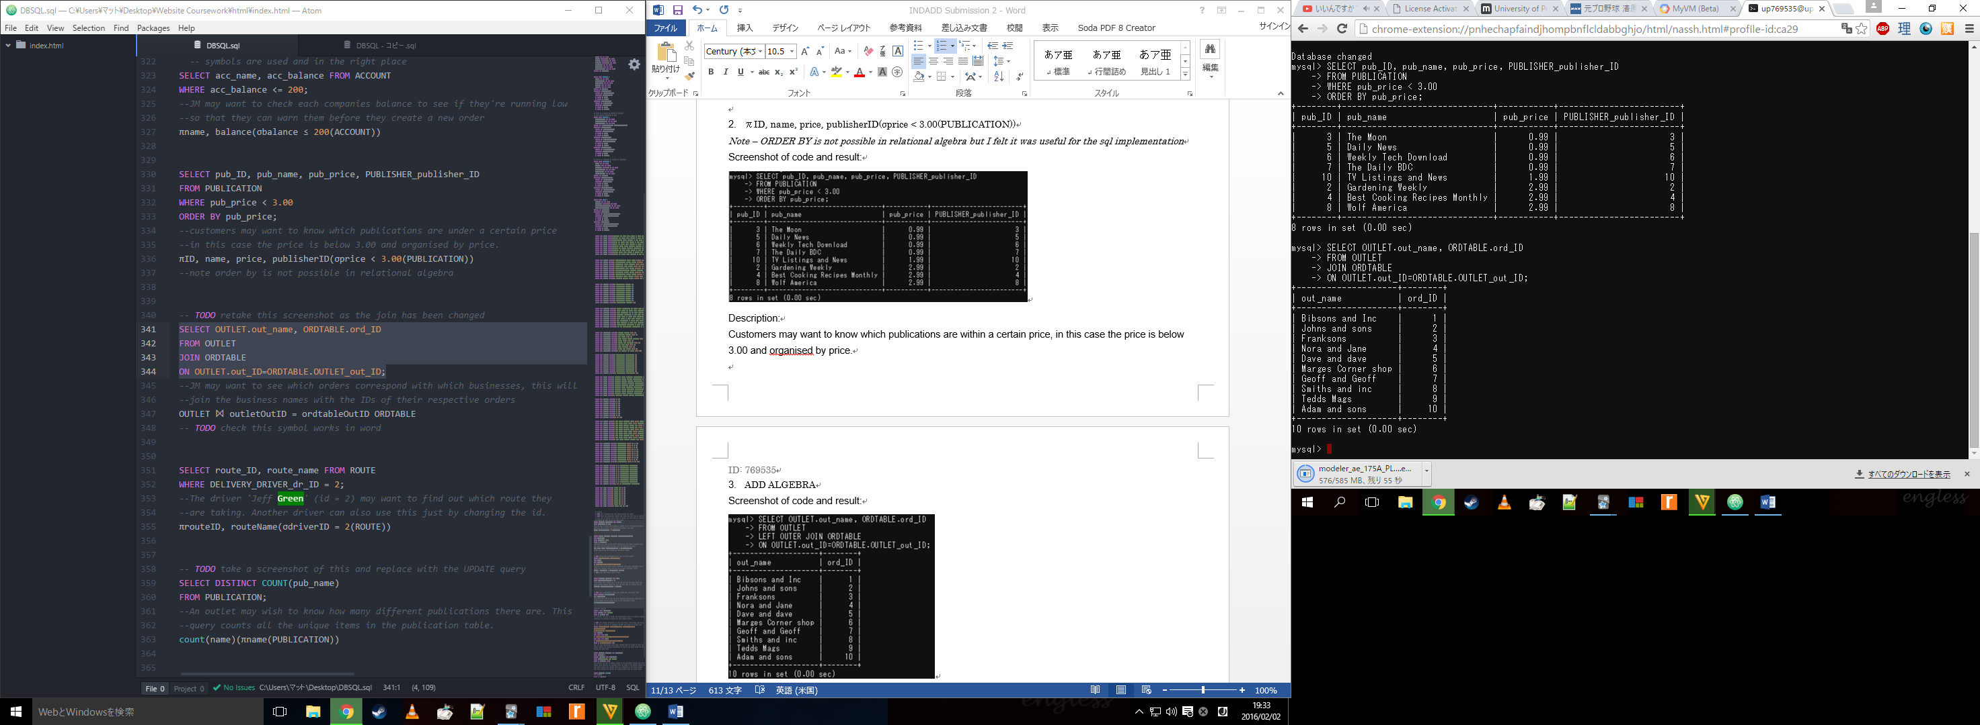

Description:

JM may want to see which orders correspond with which businesses, this will join the business names with the IDs of their respective orders.

1. πrouteID, routeName(σdriverID = 2(ROUTE))

Screenshot of code and result:

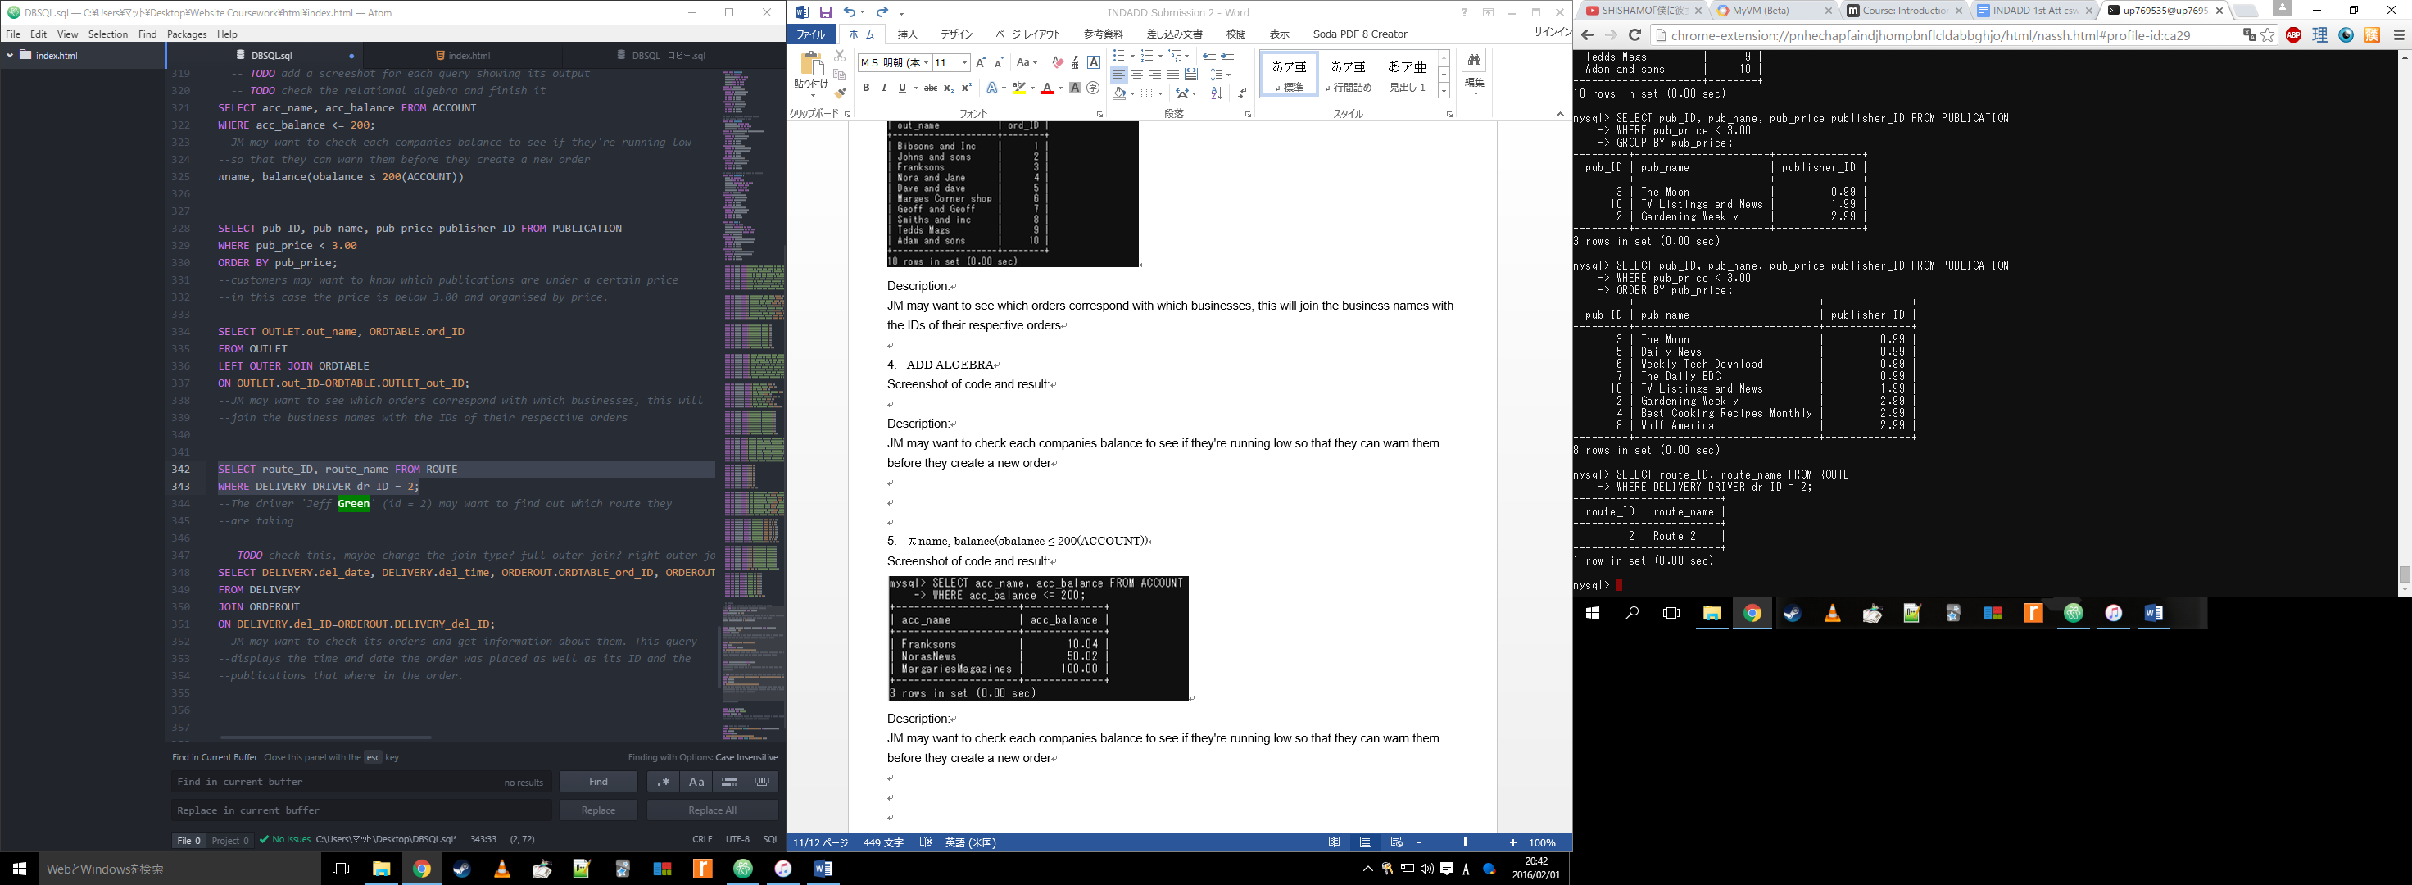

Description:

A driver, in this case 'Jeff Green' (id = 2), may want to find out which route they are taking. Another driver can also use this just by changing the id.

1. count(name)(πname(PUBLICATION))

Screenshot of code and result:

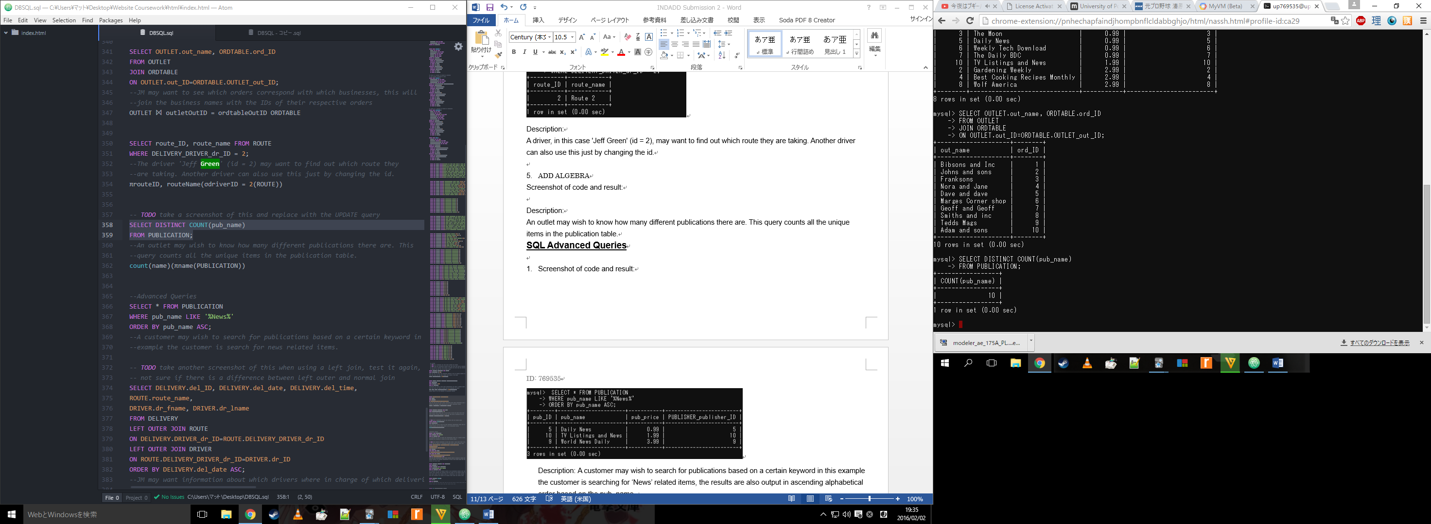

Description:

An outlet may wish to know how many different publications there are. This query counts all the unique items in the publication table.

**SQL Advanced Queries**

1. Screenshot of code and result:

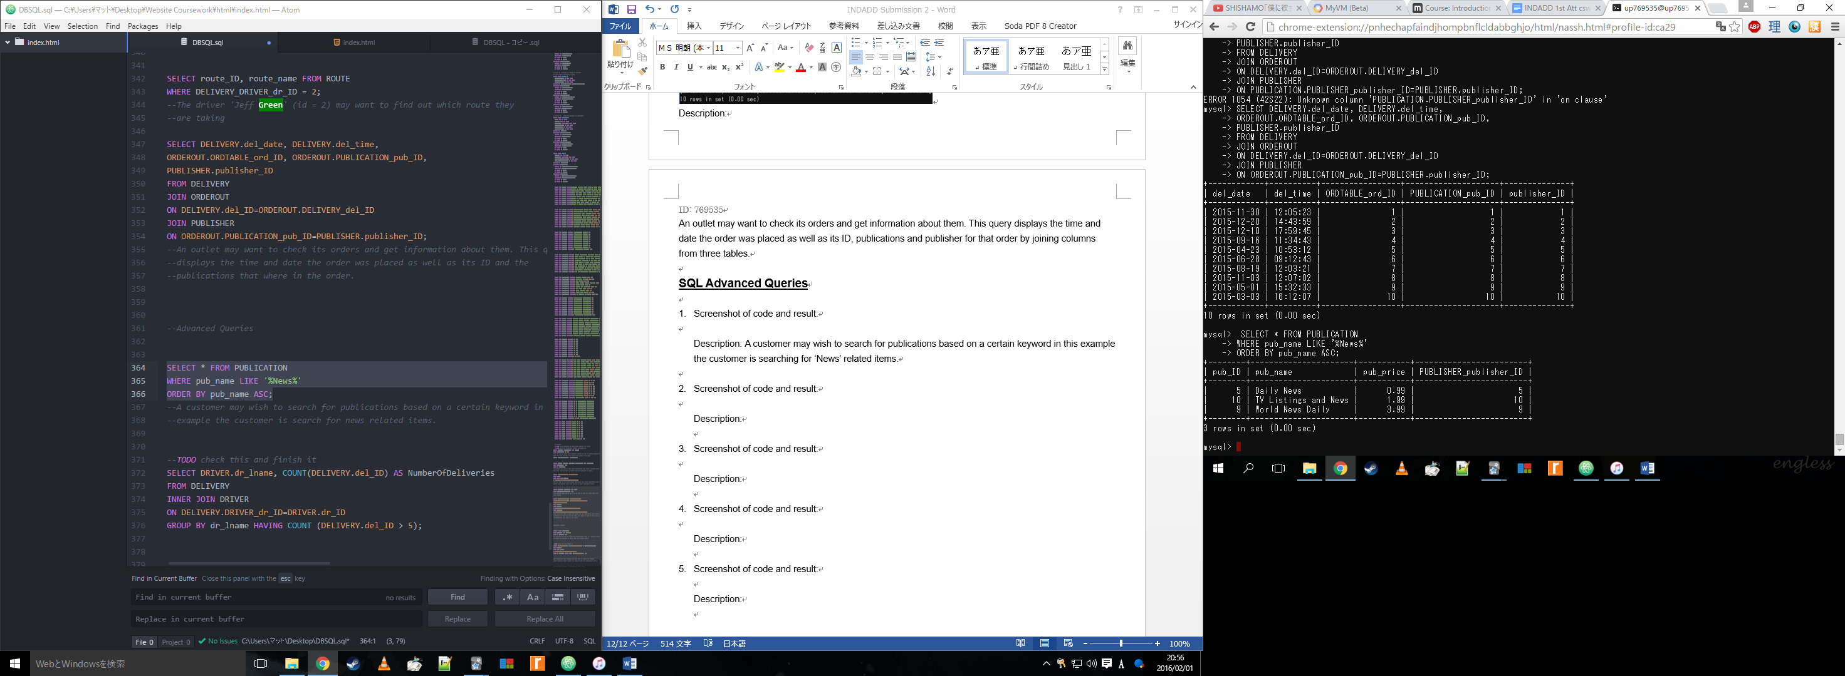

Description:

A customer may wish to search for publications based on a certain keyword in this example the customer is searching for ‘News’ related items, the results are also output in ascending alphabetical order based on the pub_name.

1. Screenshot of code and result:

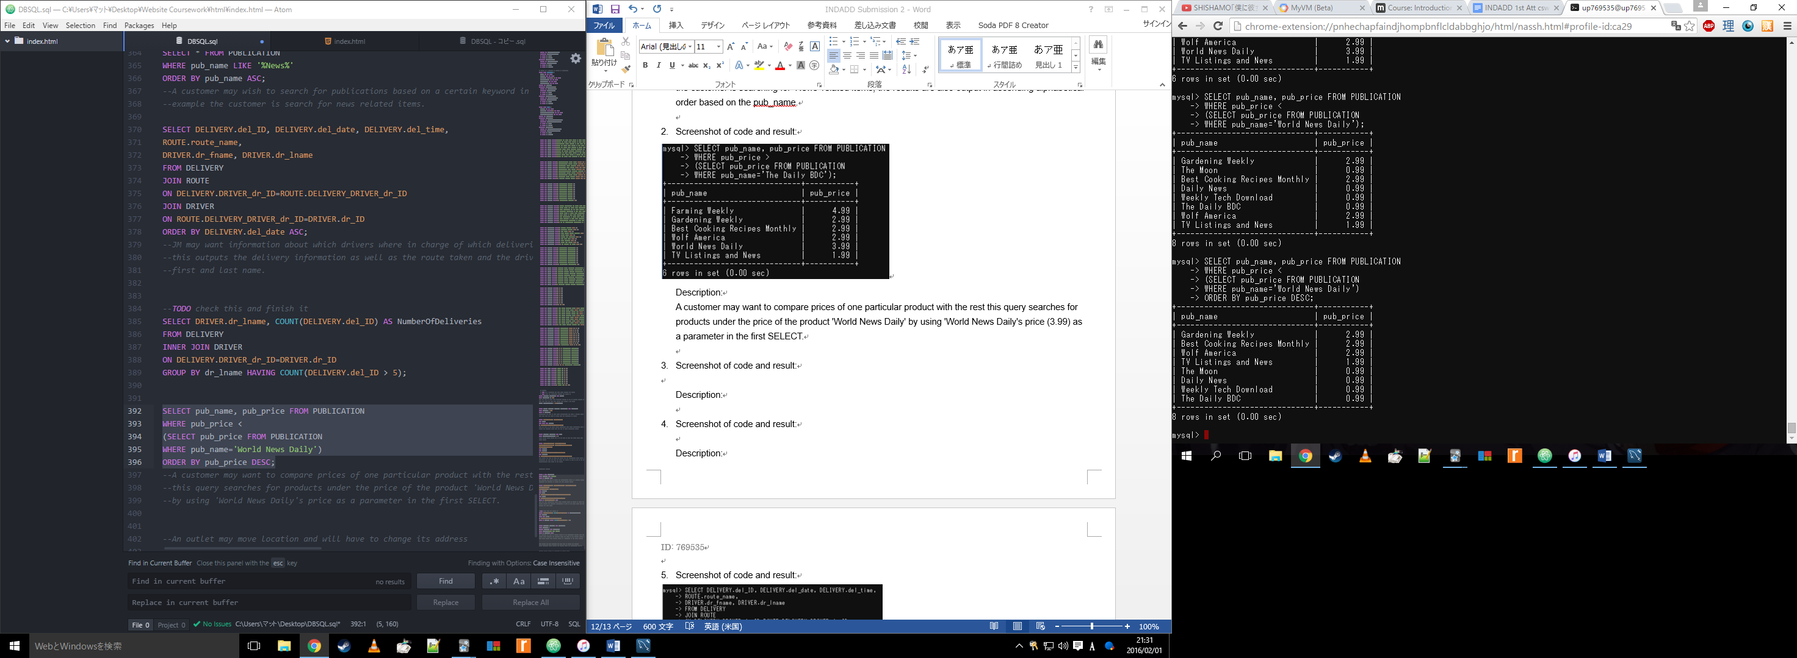

Description:

A customer may want to compare prices of one particular product with the rest. This query searches for products under the price of the product 'World News Daily' by using 'World News Daily's price (3.99) by nesting two SELECT statements. It also displays the results via highest price first and lowest last.

1. Screenshot of code and result:

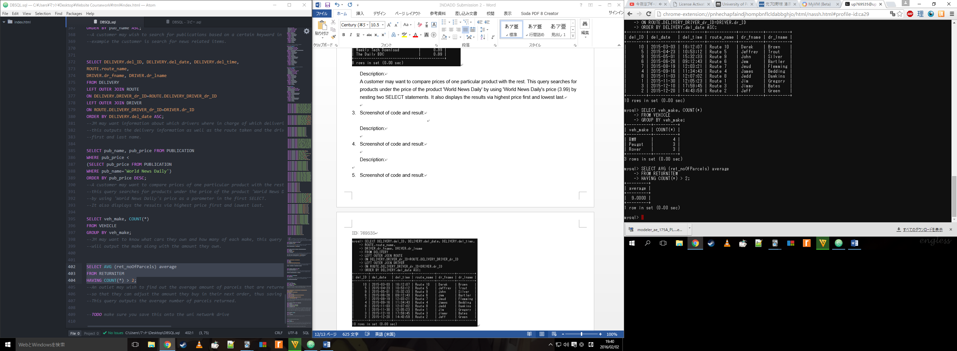

Description:

JM may want to know what cars they own and how many of each make, this query will output how many cars they own of each car make e.g. they own 4 BWM’s.

1. Screenshot of code and result:



Description:

An outlet may wish to find out the average amount of parcels that are returned so that they can adjust the amount they buy in their next order, thus saving money. This query outputs the average number of parcels returned.

1. Screenshot of code and result:

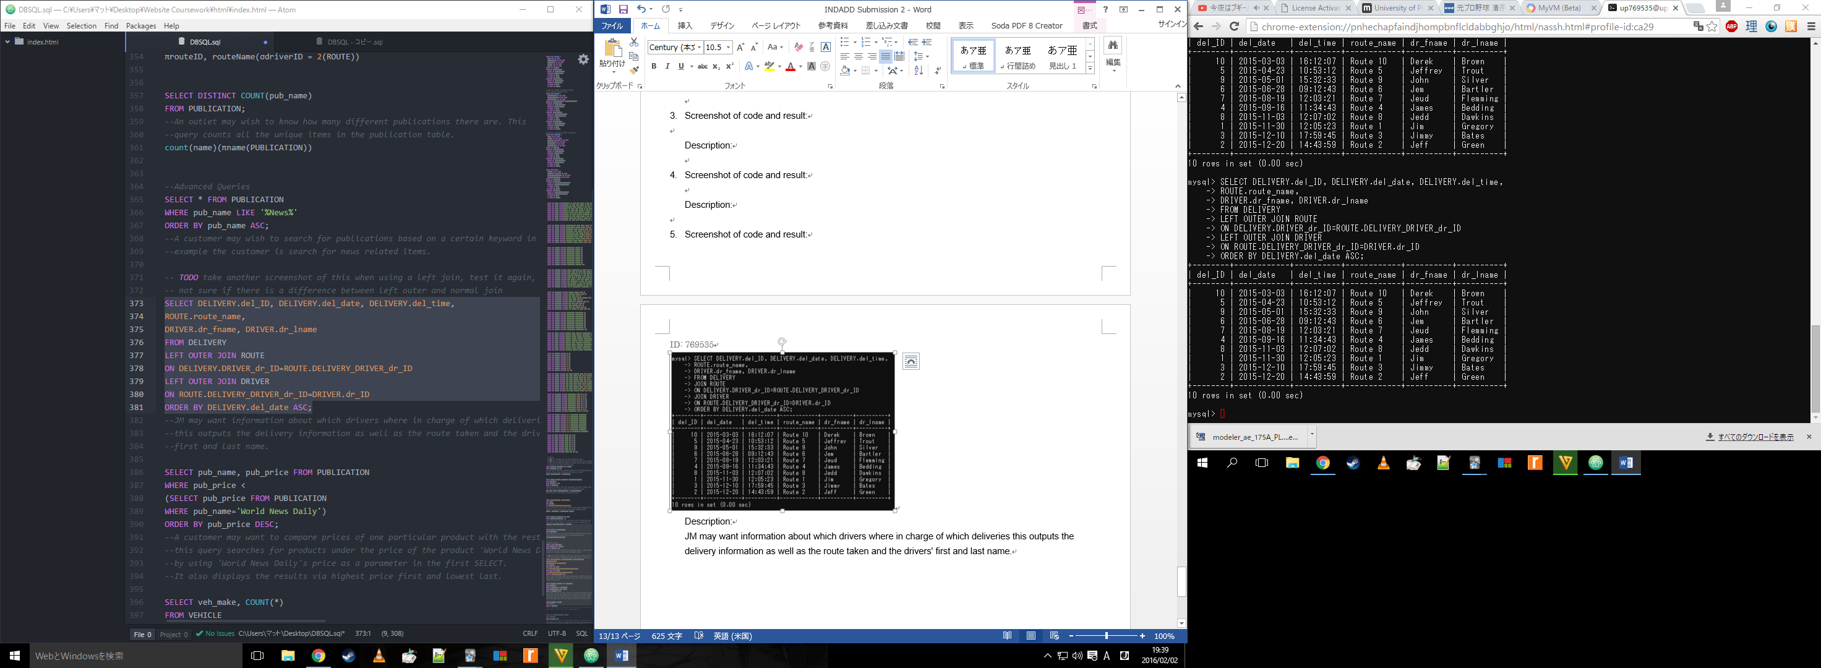

Description:

JM may want information about which drivers were in charge of which deliveries this outputs the delivery information as well as the route taken and the drivers' first and last name.